|  |  |  |
| --- | --- | --- |
|  | **PORTFOLIO PROJECT** |  |

Submitted by

**RAVISANKAR S**

**1P24MC042**

In partial fulfillment of the requirements for the award of the Degree of

#### MASTER OF COMPUTER APPLICATIONS

From Bharathiar University, Coimbatore.

Under the Internal Supervision of

## Dr. S. RANJITHA KUMARI, M.Sc., M.Phil., PhD.,

Associate Professor, Dept. of MCA, RVSCAS



## SCHOOL OF COMPUTER STUDIES MASTER OF COMPUTER APPLICATIONS

**RVS COLLEGE OF ARTS AND SCIENCE (AUTONOMOUS)**

## Sulur, Coimbatore – 641 402.

**November- 2024**

# RVS COLLEGE OF ARTS AND SCIENCE (AUTONOMOUS)

## Sulur, Coimbatore – 641 402. School of Computer Studies

**Department of Computer Applications (MCA)**



#### November- 2024.

**Register Number: 1P24MC042**

Certified bonafideoriginal record of work done by RAVISANKAR S

## Internal Supervisor Director

Submitted for the project Evaluation and *Viva-Voce* held on**………………….**

**Internal Examiner External Examiner**

# CONTENT INDEX

|  |  |
| --- | --- |
| **Chapter** | **Page No.** |
| **Chapter 1**: Video Introduction  1.1. YouTube Video | 1 |
| **Chapter 2:** Website Bio Score   * 1. About me   2. Contact Information | 2 |
| **Chapter 3**: Pages & Navigation   * 1. Landing Page   2. Navigation bar   3. Skill Page | 10 |
| **Chapter 4**: Style Score  4.1 Style links | 29 |

|  |  |
| --- | --- |
| **Chapter 5**: Website include the following Information   * 1. Project link to the GitHub   2. Project Description | 35 |
| **Chapter 6**: Bootstrap  6.1 Uses of Bootstrap | 38 |
| **Chapter 7**: Project README  Title description  How to run the project  Future improvement in the Project | 40 |
| **Chapter 8**: File structure  8.1 GitHub file Structure | 45 |

**Chapter-1**

## Video Information

* 1. **YouTube video introduction**

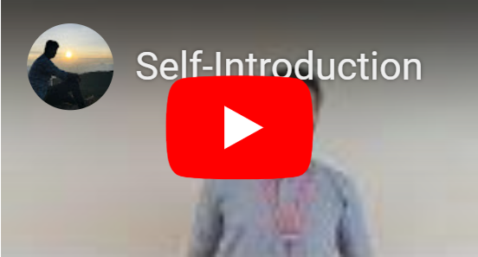

# Description:

In this page, you can see the self-introduction of mine. By clicking the play button it will redirect to the YouTube page, so that you can know me more.

## Source Code:

### HTML:

<iframe width="220" height="120"

src="https://www.youtube.com/embed/YH2h4wdrxn8?si=Y8hi5KTe3FO-DL_w” title="YouTube video player" frameborder="0" allow="accelerometer; autoplay; clipboard-write; encrypted-media; gyroscope; picture-in-picture;

web-share" referrerpolicy="strict-origin-when-cross-origin"allowfullscreen> </iframe>

# Chapter-2:

## Website Bio Score

* 1. **About Me:**



## Description:

In this page, there is an image of mine, paragraph about me and also an option called View My CV. So, that if any user want to see the resume they can directly download from here.

## Source Code:

### HTML:

<!--==================== ABOUT ====================-->

<section class="aa" id="About Me" style="z-index: 1;">

<p class="a1">About Me</p>

<div class="about">

<div class="hi1">

<img src="./ravi-removebg-preview (2).png" alt="Ravi Sankar's Profile Image">

</div>

<aside>

<div class="a2">

<div class="a3">

<p>Hi, I am Ravi Sankar, from Tamil Nadu.</p>

</div>

<div class="obj">

I am available for Portfolio Design Projects.

To secure a challenging position in a reputable organization to

expand my learnings, knowledge, and skills. Secure a responsible

career opportunity to fully utilize my training and skills,

while making a significant contribution to the success of the

company.

</div>

</div>

<div class="para">

<div class="theone">

<p>Name:</p>

<p>Email:</p>

<p>Birthday:</p>

<p>University:</p>

<p>Phone:</p>

<p>City:</p>

</div>

<div class="thetwo">

<p>Ravi Sankar S.</p>

<p>ravisankar27.09@gmail.com</p>

<p>27 September, 2003</p>

<p>Bharathiar University</p>

<p>(+91) 9677568661</p>

<p>Tiruppur, India</p>

</div>

</div>

</aside>

</div>

</section>

CSS:

/*=============== ABOUT ===============*/

.a1 {

color: #ffbf35;

text-align: center;

font-size: 30px;

padding-top: 80px;

}

.aa {

height: 700px;

background-image: url(./image\ about4.jpg);

background-repeat: no-repeat;

background-size: cover;

}

.about {

display: flex;

align-items: center;

padding: 25px;

margin: 0 auto;

max-width: 1200px;

}

.hi1 img {

width: 80%;

height: auto;

padding-bottom: 50px;

}

aside {

padding: 20px;

}

.a2 {

color: aqua;

font-size: 20px;

padding-left: 80px;

}

.a3 {

color: aqua;

font-size: 25px;

padding-bottom: 5px;

text-align: right;

}

.obj {

width: 550px;

font-size: 20px;

text-align: justify;

}

.para {

display: flex;

justify-content: space-between;

}

.para p {

padding: 0px 0px 12px 80px;

}

## Contact Page :

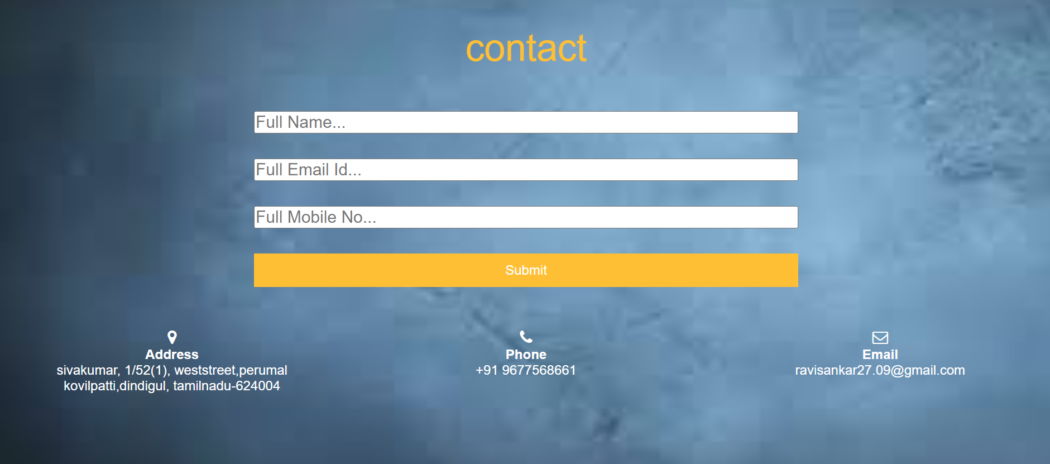

**Description:**

The above displayed figure is a contact page in the website. If the user wants to contact me, they can fill the form with their valid details. Here I imported library called Email-js to send messages.

## Source Code:

### HTML:

<!--==================== CONTACT ====================-->

<section class="contentt" id="CONTACT" style="z-index: 1;">

<div class="c1"> contact</div>

<div id="contact_form">

<div class="table">

<form>

<input type="text" placeholder="Full Name...">

<input type="text" placeholder="Full Email Id...">

<input type="text" placeholder="Full Mobile No...">

<button id="btn" type="submit">Submit</button>

</form>

</div>

</div>

<div class="contact">

<div class="cont">

<h3>

<i class="fa fa-map-marker"></i>

</h3>

<h4>Address</h4>

<p>sivakumar, 1/52(1), weststreet,perumal kovilpatti,dindigul, tamilnadu-624004</p>

</div>

<div class="cont">

<h3>

<i class="fa fa-phone"></i>

</h3>

<h4>Phone</h4>

<p>+91 9677568661</p>

</div>

<div class="cont">

<h3>

<i class="fa fa-envelope-o"></i>

</h3>

<h4>Email</h4>

<p>ravisankar27.09@gmail.com</p>

</div>

</div>

</section>

### CSS :

/*=============== CONTACT ===============*/

#CONTACT {

background-image: url(./download\ about.jpg );

background-repeat: no-repeat;

background-size: cover;

height: 700px;

}

.contentt {

margin-top: 50px;

height: 360px;

}

.c1 {

color: #ffbf35;

font-size: 45px;

text-align: center;

padding-top: 100px;

}

#contact_form {

width: 100%;

display: flex;

justify-content: center;

align-items: center;

}

form {

padding-top: 20px;

}

input {

font-size: 20px;

width: 650px;

display: flex;

margin: 30px;

}

#btn {

width: 650px;

float: left;

margin-bottom: 20px;

height: 40px;

padding: 10px;

background: #ffbf35;

color: #fff;

border: none;

font-size: 16px;

margin-left: 30px;

}

.contact {

width: 100%;

display: flex;

justify-content: space-around;

padding-bottom: 30px;

padding-top: 30px;

}

.cont {

width: 30%;

text-align: center;

}

# Chapter-3:

## Pages & Navigation

* 1. **Landing Page:**

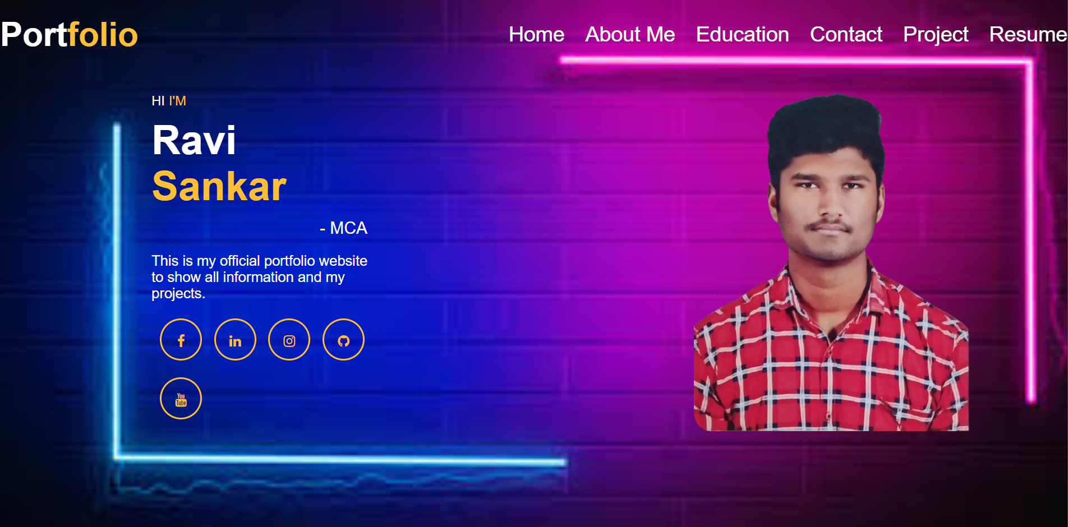

Figure 3.1.1

## Description:

The above Figure 3.1.1 are the screenshot of Homepage in a desktop view. And this is a home screen of the portfolio which shows the landing page and navigation bar. which shownas Figure 3.1.1.

## Source Code

### HTML

<!--==================== HOME ====================-->

<section class="first" id="Home" >

<div class="container" style="z-index: 99; position: fixed;">

<div class="width-33 logo">

Port<span class="span-coll">folio</span>

</div>

<a href="#about" class="btn-scroll" title="Scroll Down"><i class="bi bi-chevron-down"></i></a>

</div>

<div class="width-66">

<nav>

<a href="#Home" >Home</a>

<a href="#About Me" >About Me</a>

<a href="#Education">Education</a>

<a href="#CONTACT">Contact</a>

<a href="#projbox">Project</a>

<a href="./Black and White Modern Entry Level Fresher Resume_20231220_131247_0000 (1).pdf">Resume</a>

</nav>

</div>

</div>

<div class="container" style="z-index: 1;">

<div class="width-50" id="details">

<div class="banner-section">

<span class="span-col"><span style="color: white">HI</span> I'M</span>

<h1>Ravi <span class="span-col-oo">Sankar</span></h1>

<h2>- MCA</h2>

<p class="para">

This is my official portfolio website to show all details and my

projects.

</p>

<a href="https://www.facebook.com/skarthik.karthik.94043">

<i class="fa fa-facebook"></i></a>

<a href="https://www.linkedin.com/in/ravisankar-s-8255b2280">

<i class="fa fa-linkedin"></i>

</a>

<a href="https://www.instagram.com/ravi_villan_2003/">

<i class="fa fa-instagram"></i>

</a>

<a href="https://github.com/Sivaravisankar">

<i class="fa fa-github"></i>

</a>

<a href="https://youtu.be/YH2h4wdrxn8?si=XUhxiSzSAzlsuceO">

<i class="fa fa-youtube"></i>

</a>

</div>

</div>

<div class="width-50 remo">

<div class="hi">

<img src="./WhatsApp_Image_2024-08-20_at_1.55.02_PM-removebg-preview.png" alt="Ravi Sankar's Profile Image"/>

</div>

</div>

</div>

</section>

### CSS:

/*=============== HOME ===============*/

.first{

background-image: url(./rgp.jpeg);

background-repeat: no-repeat;

background-size: cover;

}

.container {

width: 100%;

margin: 0 auto;

display: flex;

justify-content: space-between;

align-items: center;

}

.width-33 {

width: 30%;

}

.width-66 {

width: 66%;

display: flex;

justify-content: flex-end;

}

.width-66 a {

font-size: 25px;

font-weight: 500;

color: white;

margin-left: 20px;

text-decoration: none;

}

.width-66 a:hover {

color: #ffbf35;

}

.first {

padding: 20px 0 50px;

min-height: 100vh;

}

#details {

padding-left: 180px;

padding-top: 50px;

}

.logo {

font-size: 40px;

font-weight: 600;

}

.span-col{

color: #ffbf35;

padding-left: 80px;

font-size: 25px;

}

.span-coll{

color: #ffbf35;

}

.span-col-oo {

color: #ffbf35;

}

.width-50 {

width: 35%;

}

.para {

color: #fff;

font-size: 17px;

margin-top: 1em;

padding-left: 80px;

}

.banner-section {

margin-top: 50px;

}

.banner-section h1 {

font-size: 48px;

margin-top: 10px;

font-weight: bolder;

padding-left: 80px;

}

.banner-section h2 {

font-size: 20px;

line-height: 25px;

margin-top: 10px;

font-weight: 400;

padding-left: 330px;

}

.banner-section a {

margin-top: 30px;

margin-left: 30px;

border-radius: 50%;

text-align: center;

border: 2px solid #ffbf35;

color: #ffbf35;

height: 50px;

width: 50px;

line-height: 50px;

display: inline-block;

}

.hi img {

margin-top: 8%;

/* margin-left: 10%; */

width: 100%;

max-width: 450px;

height: auto;

padding-right: 70px;

border-radius: 5%;

padding-top: 150px;

}

## Project Page

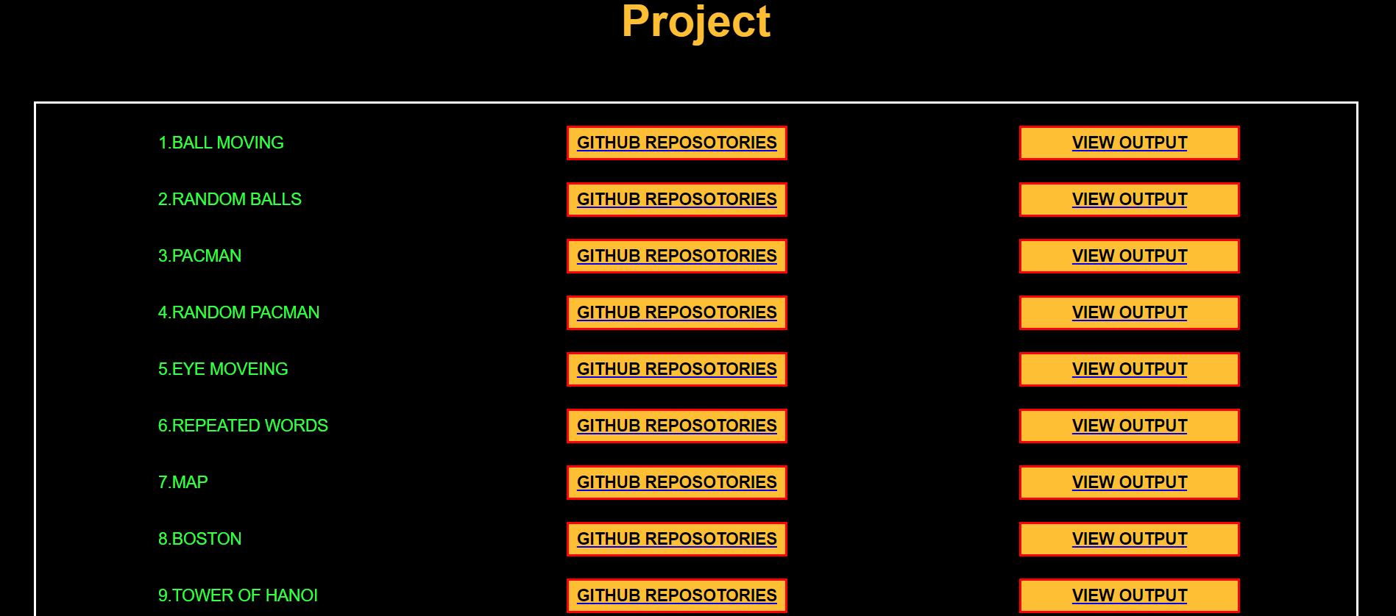

**Source Code**

### HTML:

<!-- ==================== PROJECTS ==================== -->

<section id="project" style="padding-top: 200px;">

<div class="pro" id="pro">

<h2>Project</h2>

<div style="width: 100%; " id="projectbox">

<div id="projbox">

<div id="prolist">

<p class="ball" class="btnproj">1.BALL MOVING</p>

<p class="ball" class="btnproj">2.RANDOM BALLS</p>

<p class="ball" class="btnproj">3.PACMAN</p>

<p class="ball" class="btnproj">4.RANDOM PACMAN</p>

<p class="ball" class="btnproj">5.EYE MOVEING</p>

<p class="ball" class="btnproj">6.REPEATED WORDS</p>

<p class="ball" class="btnproj">7.MAP</p>

<p class="ball" class="btnproj">8.BOSTON</p>

<p class="ball" class="btnproj">9.TOWER OF HANOI</p>

</div>

<div id="prolist">

<a href="https://github.com/Sivaravisankar/BALL-MOVING"><button class="btnproj"

id="projbtn">GITHUB

REPOSOTORIES</button></a>

<a href="https://github.com/Sivaravisankar/three-ball-move"><button class="btnproj" id="projbtn">GITHUB

REPOSOTORIES</button></a>

<a href="https://github.com/Sivaravisankar/pacman"><button class="btnproj" id="projbtn">GITHUB

REPOSOTORIES</button></a>

<a href="https://github.com/Sivaravisankar/Random-pacman"><button class="btnproj" id="projbtn">GITHUB

REPOSOTORIES</button></a>

<a href="https://github.com/Sivaravisankar/eyes-move"><button class="btnproj" id="projbtn">GITHUB

REPOSOTORIES</button></a>

<a href="https://github.com/Sivaravisankar/REPEATED-WORDS"><button class="btnproj" id="projbtn">GITHUB

REPOSOTORIES</button></a>

<a href="https://github.com/Sivaravisankar/map"><button class="btnproj" id="projbtn">GITHUB

REPOSOTORIES</button></a>

<a href="https://github.com/Sivaravisankar/Boston"><button class="btnproj" id="projbtn">GITHUB

REPOSOTORIES</button></a>

<a href="https://github.com/Sivaravisankar/map"><button class="btnproj" id="projbtn">GITHUB

REPOSOTORIES</button></a>

</div>

<div id="prolist">

<a href="https://sivaravisankar.github.io/BALL-MOVING/"><button class="btnproj" id="projbtn">VIEW

OUTPUT</button></a>

<a href="https://sivaravisankar.github.io/three-ball-move/"><button class="btnproj" id="projbtn">VIEW

OUTPUT</button></a>

<a href="https://sivaravisankar.github.io/pacman/"><button class="btnproj" id="projbtn">VIEW

OUTPUT</button></a>

<a href="https://sivaravisankar.github.io/Random-pacman/"><button class="btnproj" id="projbtn">VIEW

OUTPUT</button></a>

<a href="https://sivaravisankar.github.io/eyes-move/"><button class="btnproj" id="projbtn">VIEW

OUTPUT</button></a>

<a href="https://sivaravisankar.github.io/REPEATED-WORDS/"><button class="btnproj" id="projbtn">VIEW

OUTPUT</button></a>

<a href="https://sivaravisankar.github.io/map/"><button class="btnproj" id="projbtn">VIEW

OUTPUT</button></a>

<a href="https://sivaravisankar.github.io/Boston/"><button class="btnproj" id="projbtn">VIEW

OUTPUT</button></a>

<a href="https://sivaravisankar.github.io/map/"><button class="btnproj" id="projbtn">VIEW

OUTPUT</button></a>

</div>

</div>

</div>

</div>

</section>

### CSS:

/*=============== PROJECTS ===============*/

.pro h2 {

text-align: center;

font-size: 40px;

color: #ffbf35;

padding-top: 100px;

}

.pro {

width: 100%;

}

.pro>div {

font-size: 25px;

padding-top: 50px;

padding-bottom: 50px;

display: flex;

justify-content: space-around;

}

#projectbox {

width: 100%;

display: flex;

justify-content: center;

}

#projbox {

display: flex;

padding-top: 20px;

justify-content: space-around;

width: 1200px;

border: 2px solid white;

}

.btnproj {

display: block;

}

#projbtn {

color: black;

background-color: #ffbf35;

border: 2px solid red;

padding: 5px 4px;

margin-bottom: 20px;

font-weight: bold;

width: 200px;

font-size: 15px;

}

#projlist {

border: none;

width: 95%;

display: flex;

justify-content: space-around;

align-items: center;

border-bottom: 2px solid white;

padding: 10px;

margin: 10px 0px;

margin-left: 28px;

}

#projlist:last-child {

border-bottom: none;

}

.ball {

border: 2px solid transparent;

margin-bottom: 20px;

display: block;

color: #35ff46;

font-size: 15px;

padding: 5px 4px;

}

## Navigation Bar

### 

### Desktop View



Figure-3.3.1

## Description:

The Figure-3.3.1 are the samples of navigation bar in both desktop View.This was a user-friendlymethod only, so the user can easily use the features.

## Source Code

### HTML:

<!--==================== HEADER ====================-->

<div class="container" style="z-index: 99; position: fixed;">

<div class="width-33 logo">

Port<span class="span-coll">folio</span>

</div>

<div class="width-66">

<nav>

<a href="#Home" >Home</a>

<a href="#About Me" >About Me</a>

<a href="#Education">Education</a>

<a href="#CONTACT">Contact</a>

<a href="#projbox">Project</a>

<a href="./Black and White Modern Entry Level Fresher Resume_20231220_131247_0000 (1).pdf"

>Resume</a>

</nav>

</div>

</div>

### CSS:

/*=============== HEADER & NAV ===============*/

* {

box-sizing: border-box;

margin: 0;

padding: 0;

outline: 0;

font-family: Arial, Helvetica, sans-serif;

}

html, body {

background: #000000;

color: #fff;

height: 100%;

}

.container {

width: 100%;

margin: 0 auto;

display: flex;

justify-content: space-between;

align-items: center;

}

.width-33 {

width: 30%;

}

.width-66 {

width: 66%;

display: flex;

justify-content: flex-end;

}

.width-66 a {

font-size: 25px;

font-weight: 500;

color: white;

margin-left: 20px;

text-decoration: none;

}

.width-66 a:hover {

color: #ffbf35;

}

**3.4. Skills:**

## Description:

The above figures are skill page, which contain a subdivision named skills and expertise,education and training, soft skills and self-introduction video. Basically, it is an animation, when the user load the page and click the specified box it will toggle with border with orange color.

## Source Code:

### HTML:

<!--==================== Skills ====================-->

<section class="b1" id="Education" style="z-index: 1;">

<div class="b2">Education & My Skills</div>

<div id="education_cont">

<div class="bg-lightgrey">

<div class="experience-list">

<div class="experience-count"></div>

<h2>BHARATHIAR UNIVERSITY</h2>

<p>R.V.S College of Arts & Science</p>

<p>Bachelor in Computer Applications (2021-2024)</p>

<h3></h3>

</div>

<div class="experience-list">

<div class="experience-count"></div>

<h2>BHARATHIAR UNIVERSITY</h2>

<p>R.V.S College of Arts & Science</p>

<p>Master in Computer Applications (2024-2026)</p>

</div>

<div class="experience-list">

<div class="experience-count"></div>

<h2>State Board</h2>

<p>Vallalar Gurukulam Hr Sec School (2018-2019)</p>

<p>Secondary School</p>

</div>

<div class="experience-list">

<div class="experience-count"></div>

<h2>State Board</h2>

<p>Vallalar Gurukulam Hr Sec School</p>

<p>Higher Secondary School (2020-2021)</p>

</div>

</div>

</div>

</div>

<aside class="opp">

<div class="skill">

<b>HTML</b>

<span>90%</span>

<div>

<span style="width: 90%"></span>

</div>

</div>

<div class="skill">

<b>CSS</b>

<span>85%</span>

<div>

<span style="width: 85%"></span>

</div>

</div>

<div class="skill">

<b>JavaScript</b>

<span>50%</span>

<div>

<span style="width: 50%"></span>

</div>

</div>

</aside>

<div class="CERTIFICATES">CERTIFICATES</div>

<div class="type">

<li class="link1"><a href="./RAVI SANKAR S (7).pdf">python basic programs</a></li>

<li class="link2"><a href="./RAVI SANKAR S (6).pdf">Front End Development-HTML</a></li>

</div>

</section>

### CSS:

/*=============== Skills ===============*/

.bg-lightgrey{

border: 5px solid black;

height: 300px;

width: 800px;

margin-left: 280px;

background: linear-gradient(red,orange);

}

.b2 {

color: #ffbf35;

text-align: center;

font-size: 30px;

padding: 90px 0;

padding-bottom: 20px;

}

.skill {

margin-top: 30px;

font-size: 17px;

}

.skill span {

float: right;

}

.skill div {

width: 100%;

float: left;

margin-top: 5px;

background: #e7e7e7;

border-radius: 10px;

}

.skill div span {

background: #ffbf35;

height: 5px;

float: left;

}

.bg-lightgrey {

background-color: #1a1a1a;

}

.experience-list {

width: 50%;

float: left;

padding: 30px 10px;

margin-bottom: 20px;

padding-left: 40px;

}

.experience-content {

width: 100%;

float: left;

}

.experience-content h2 {

font-weight: 600;

margin-bottom: 5px;

font-size: 20px;

}

.experience-content h3 {

color: #ffbf35;

font-weight: 500;

margin-bottom: 2px;

font-size: 17px;

}

.experience-content p {

font-size: 15px;

}

.opp {

padding: 10px 0px;

width: 48%;

margin: 1%;

float: right;

padding-left: 0px;

}

#education_cont {

width: 100%;

display: flex;

justify-content: center;

margin-left: -150px;

}

.CERTIFICATES {

padding-top: 30px;

color: #ffbf35;

font-size: 30px;

text-align: left;

padding-left: 40px;

}

.link1 a {

text-decoration: none;

color: #35ff46;

}

.link2 a {

text-decoration: none;

color: #35ff46;

}

.link1 {

color: #35ff46;

text-align: left;

padding-left: 150px;

padding-bottom: 40px;

padding-top: 30px;

}

.link2 {

color: #35ff50;

text-align: left;

padding-left: 150px;

padding-bottom: 40px;

padding-top: 5px;

}

# Chapter-4 Style Score

## Styles

**Source Code:**

### CSS:

/*=============== REUSABLE CSS CLASSES ===============*/

.container {

width: 100%;

margin: 0 auto;

display: flex;

justify-content: space-between;

align-items: center;

}

.width-33 {

width: 30%;

}

.width-66 {

width: 66%;

display: flex;

justify-content: flex-end;

}

.width-66 a {

font-size: 25px;

font-weight: 500;

color: white;

margin-left: 20px;

text-decoration: none;

}

.width-66 a:hover {

color: #ffbf35;

}

.first {

padding: 20px 0 50px;

min-height: 100vh;

}

#details {

padding-left: 180px;

padding-top: 50px;

}

.logo {

font-size: 40px;

font-weight: 600;

}

.span-col, .span-coll, .span-col-oo {

color: #ffbf35;

}

.width-50 {

width: 35%;

}

.para {

color: #fff;

font-size: 17px;

margin-top: 1em;

}

.banner-section {

margin-top: 25px;

}

.banner-section h1 {

font-size: 48px;

margin-top: 10px;

font-weight: bolder;

}

.banner-section h2 {

font-size: 20px;

line-height: 25px;

margin-top: 10px;

font-weight: 400;

padding-left: 200px;

}

.banner-section a {

margin-top: 20px;

margin-left: 10px;

border-radius: 50%;

text-align: center;

border: 2px solid #ffbf35;

color: #ffbf35;

height: 50px;

width: 50px;

line-height: 50px;

display: inline-block;

}

.hi img {

margin-top: 8%;

width: 100%;

max-width: 400px;

height: auto;

padding-right: 70px;

border-radius: 5%;

padding-top: 40px;

}

.a1 {

color: #ffbf35;

text-align: center;

font-size: 30px;

padding-top: 80px;

}

.about {

display: flex;

align-items: center;

padding: 25px;

margin: 0 auto;

max-width: 1200px;

}

.hi1 img {

width: 80%;

height: auto;

padding-bottom: 50px;

}

aside {

padding: 20px;

}

.a2 {

color: aqua;

font-size: 20px;

padding-left: 80px;

}

.a3 {

color: aqua;

font-size: 25px;

padding-bottom: 5px;

text-align: right;

}

.obj {

width: 550px;

font-size: 20px;

text-align: justify;

}

.para {

display: flex;

justify-content: space-between;

}

.para p {

padding: 0px 0px 12px 80px;

}

.bg-lightgrey{

border: 5px solid black;

height: 300px;

width: 800px;

margin-left: 280px;

background: linear-gradient(red,orange);

}

.b2 {

color: #ffbf35;

text-align: center;

font-size: 30px;

padding: 90px 0;

padding-bottom: 20px;

}

.skill {

margin-top: 30px;

font-size: 17px;

}

.skill span {

float: right;

}

.skill div {

width: 100%;

float: left;

margin-top: 5px;

background: #e7e7e7;

border-radius: 10px;

}

.skill div span {

background: #ffbf35;

height: 5px;

float: left;

}

## Style Links

<!--=============== FAVICON ===============-->

href="https://maxcdn.bootstrapcdn.com/font-awesome/4.7.0/css/font-awesome.min.css">

<!--=============== CSS ===============-->

<link rel="stylesheet" href="./css.css">

**Chapter 5:**

## Website include the following Information

**5.1 Project links to GitHub:**

**Project-1**

Title: **BALL MOVEMENT**

Link:https://sivaravisankar.github.io/BALL-MOVING/

* **Project Description:**

This HTML page displays a continuous bouncing red ball animation within a rectangular area, controlled by JavaScript using the setInterval function with a 500-millisecond interval.

**Project-2**

Title: **RANDOM BALL**

Link[:](https://vignesh-mca23.github.io/Random_Ball/)  https://sivaravisankar.github.io/three-ball-move/

* **Project Description:**

Elevate the animation by enabling user input for modifying the ball's movement, incorporating elements like keyboard and mouse controls, as well as introducing obstacles or targets to enhance interactivity..

**PROJECT-3**

Title: **PAC-MAN**

Link: https://sivaravisankar.github.io/pacman/

* **Project Description:**

This HTML page features a Pac-Man animation moving horizontally within a container, controlled by JavaScript for direction, mouth animation, and boundary reversal, with a continuous animation loop triggered by setinterval every 100 milliseconds.

**PROJECT-4**

Title: **RANDOM PACMAN**

Link: https://sivaravisankar.github.io/Random-pacman/

* **Project Description:**

The Random Pac_Man Simulation is a fun and interactive web application that demonstrates basic physics with moving and bouncing objects on the screen. This project primarily uses HTML and JavaScript to create and animate Pac-Man-like balls that bounce off the edges of the browser window.

**PROJECT-5**

Title: **EYE MOVING**

Link: https://sivaravisankar.github.io/eyes-move/

* **Project Description:**

This HTML document creates a simple interactive face with moving eyes that follow the user's mouse cursor. The face consists of a yellow circle with two eyes, and the eyes' black pupils follow the mouse movement.

**PROJECT-6**

Title: **MAP**

Link: https://sivaravisankar.github.io/map/

* **Project Description:**

This HTML document displays a map using Mapbox and a button to animate a marker's movement along predefined bus stops between Gandhipuram and Sulur.

**Project-7**

Title: **BOSTON**

Link: https://sivaravisankar.github.io/Boston/

* **Project Description:**

This JavaScript program retrieves and displays information about the top five earning employees in Boston, providing key details for each employee.

**Project-8**

Title: REPEATE WORDS

Link: https://sivaravisankar.github.io/REPEATED-WORDS/

* **Project Description:**

This HTML document displays the top 3 most frequently occurring words from a provided paragraph after removing punctuation and converting all text to lowercase..

**Project-9**

Title: **HANOI TOWER**

Link: https://sivaravisankar.github.io/hanoi-tower/

* **Project Description:**

The Tower of Hanoi is a classic puzzle where the objective is to move a stack of disks from one

peg to another .

# Chapter-6:

## Bootstrap

**6.1 Uses of Bootstrap:**

**Source Code**

<!------------------Bootstrap ------------------>

href="https://maxcdn.bootstrapcdn.com/font-awesome/4.7.0/css/font-awesome.min.css"

**Description:**

I have used bootstrap in this website as a separate file. Which was a built in html file and icons this website

Html:

<a href="https://www.facebook.com/skarthik.karthik.94043">

<i class="fa fa-facebook"></i></a>

<a href="https://www.linkedin.com/in/ravisankar-s-8255b2280">

<i class="fa fa-linkedin"></i>

</a>

<a href="https://www.instagram.com/ravi_villan_2003/">

<i class="fa fa-instagram"></i>

</a>

<a href="https://github.com/Sivaravisankar">

<i class="fa fa-github"></i>

</a>

<a href="https://youtu.be/YH2h4wdrxn8?si=XUhxiSzSAzlsuceO">

<i class="fa fa-youtube"></i>

</a>

<h3>

<i class="fa fa-map-marker"></i>

</h3>

<h4>Address</h4>

<p>sivakumar, 1/52(1), weststreet,perumal kovilpatti,dindigul, tamilnadu-624004</p>

</div>

<div class="cont">

<h3>

<i class="fa fa-phone"></i>

</h3>

<h4>Phone</h4>

<p>+91 9677568661</p>

</div>

<div class="cont">

<h3>

<i class="fa fa-envelope-o"></i>

</h3>

# Chapter 7:

## Project README

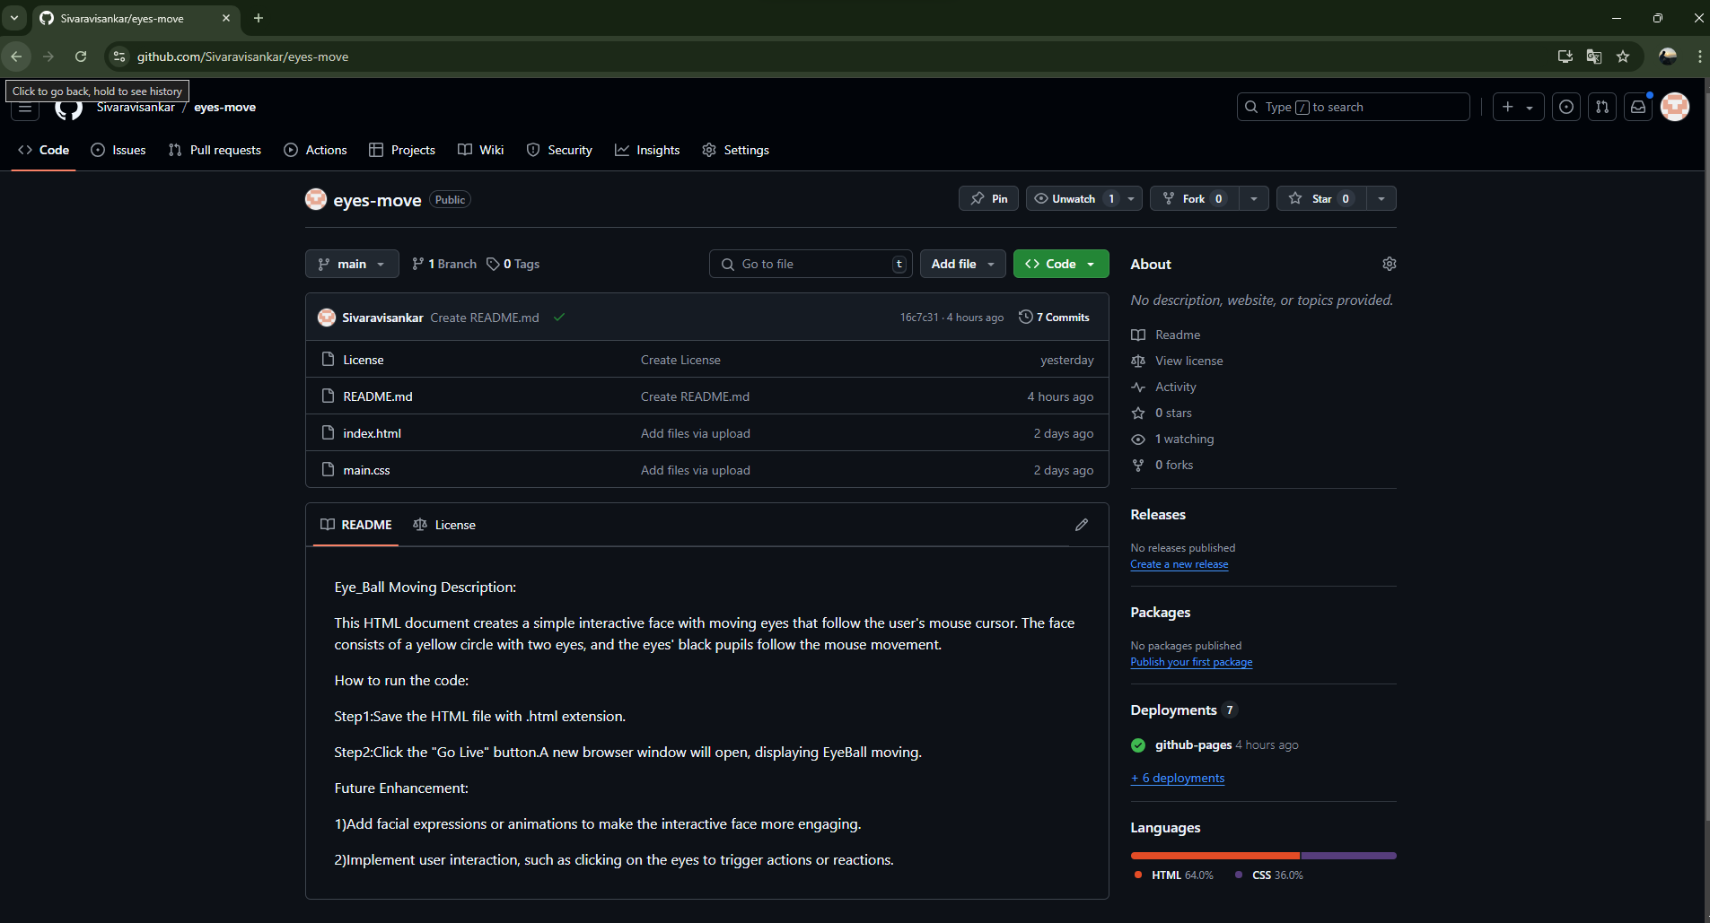

**Description:**

The above figures are the screenshot of project README files (Description, steps to run, futureimprovement) in a desktop view.

# Chapter 8

## File Structure

**8.1 GitHub File Structure**

Figure 8.1.1

Figure 8.1.2

Figure 8.1.3

Figure 8.1.4

Figure 8.1.5

Figure 8.1.6

Figure 8.1.7

Figure 8.1.8

Figure 8.1.9

**Description:**

This above Figures 8.1.1, 8.1.2, 8.1.3, 8.1.4, 8.1.5, 8.1.6, 8.1.7, 8.1.8, 8.1.9 shows GitHub File Structure in desktop.